**Web Analytics -- Lab 1 Weibo crawling using sinaweibopy**

**Step 1: Creating a Sina Weibo Account**

If you already have one, skip this step.

**Step 2: Set up Open Weibo Account and Register an Application**

To use the API you need 3 things: App key, App secrete and Redirect URI.

1. Go to <http://open.weibo.com/>, and sign in.
2. Hover your mouse over your username in the top right of the screen, and choose the first option in the menu that pops, and complete your basic information.

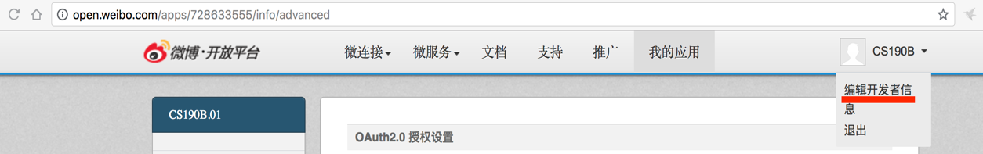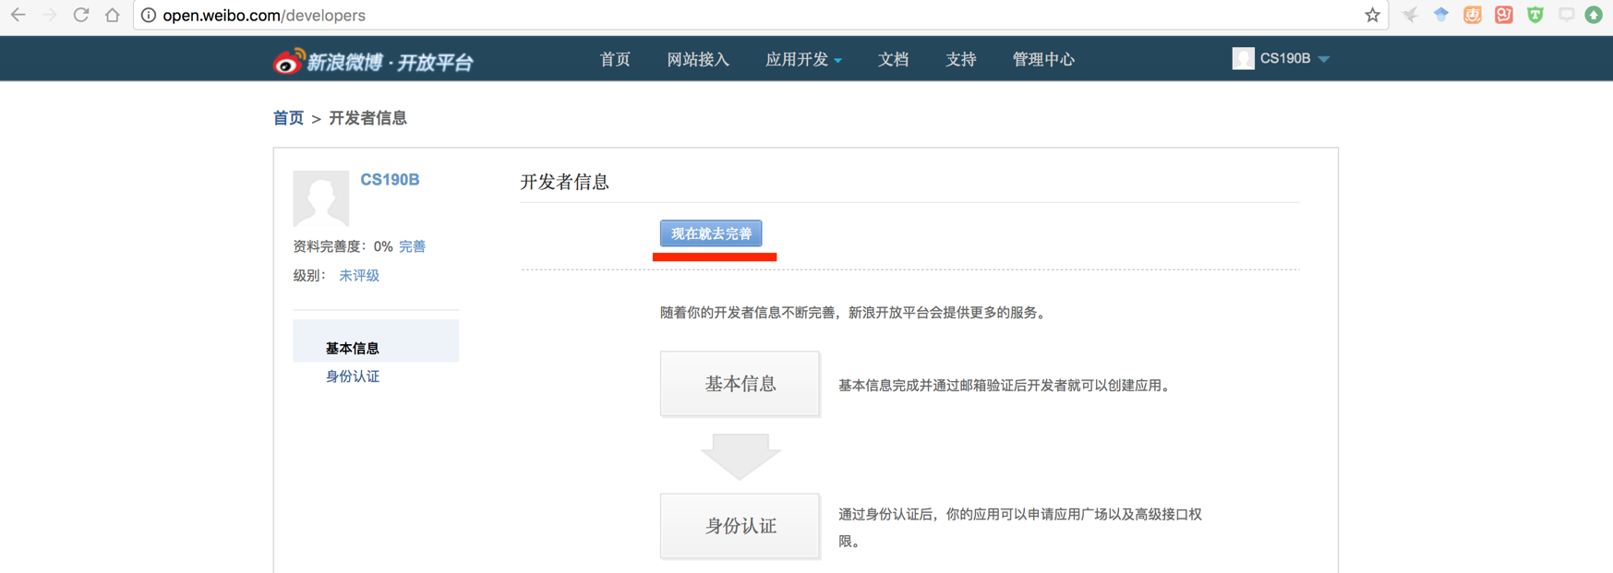

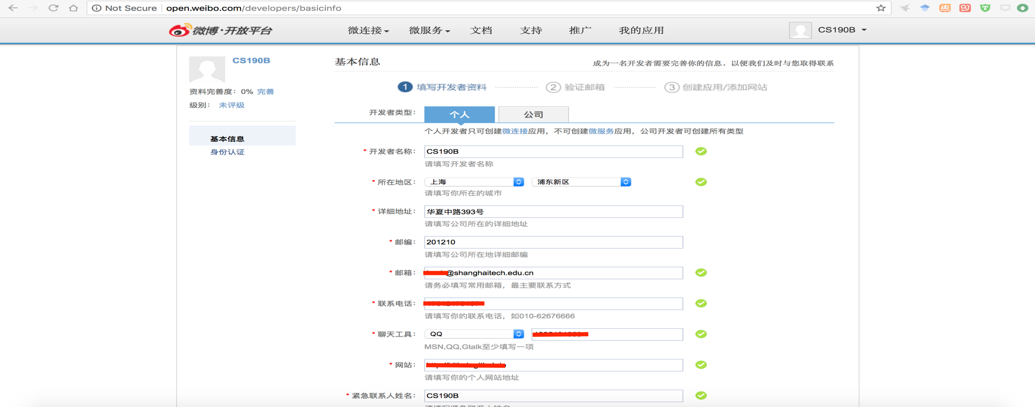

1. After that, you will be sent an activation email. Open your email account and you should see an new email, confirm it and you should be redirected to the initial webpage.

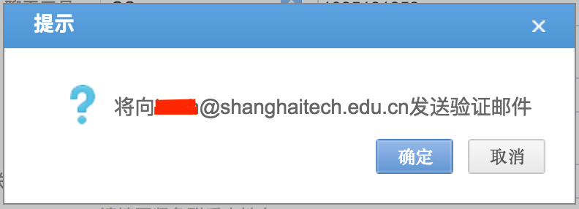

1. On the top bar, click on the button “微连接” and “网站接入” in the dropping list. Then, an app will be created.

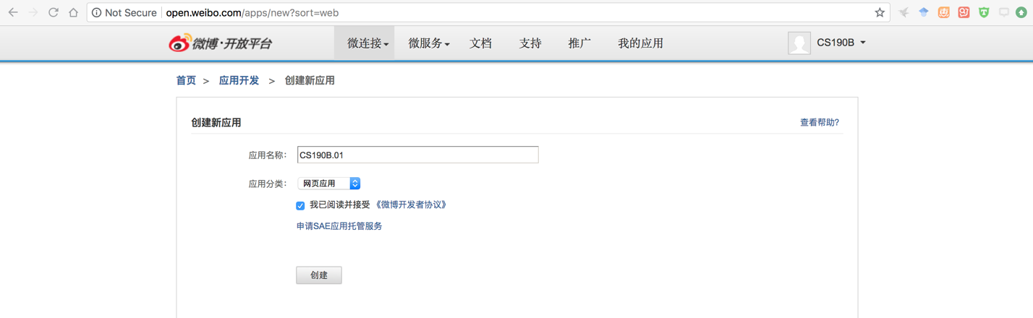

1. After you click the button “创建” in the last step, you should be redirected to your applications main page. You will be able to find the “App key” and “App Secrete” in “基本信息”. Here we got “728633555” and “7e4a0d2a476013e5adccda4105463bdc” separately.

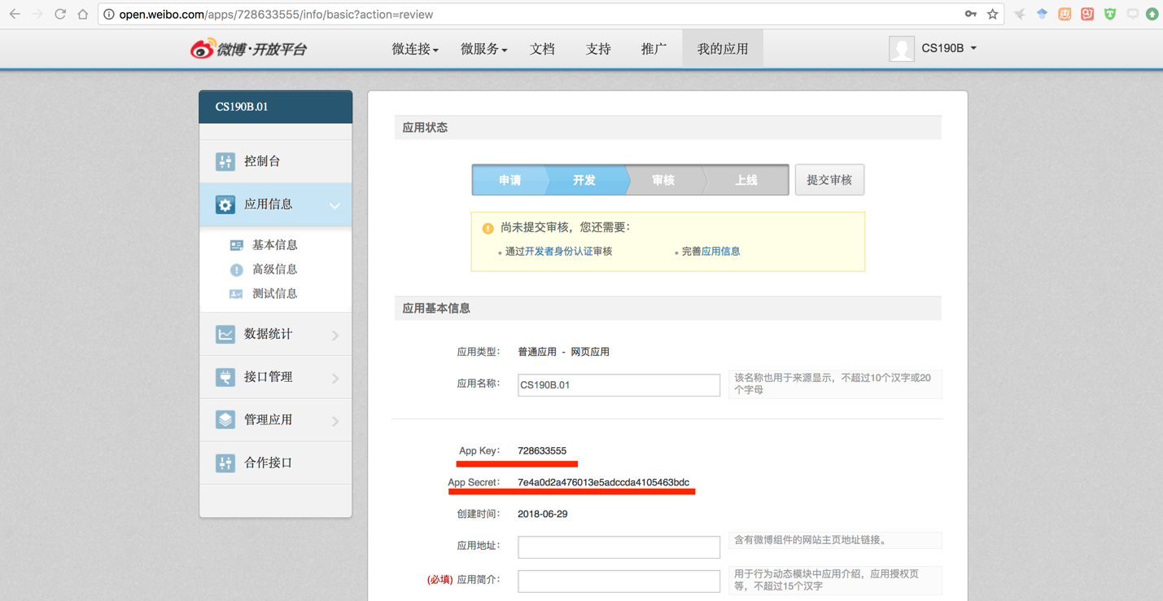

1. To set a **Redirect URI**, first click on the second button(高级信息=advanced information) in the submenu that should be open now. Then, you should see a bar with the words "OAuth2.0 授权设置". To edit this, click on the button on the right side of that bar(编辑=edit).

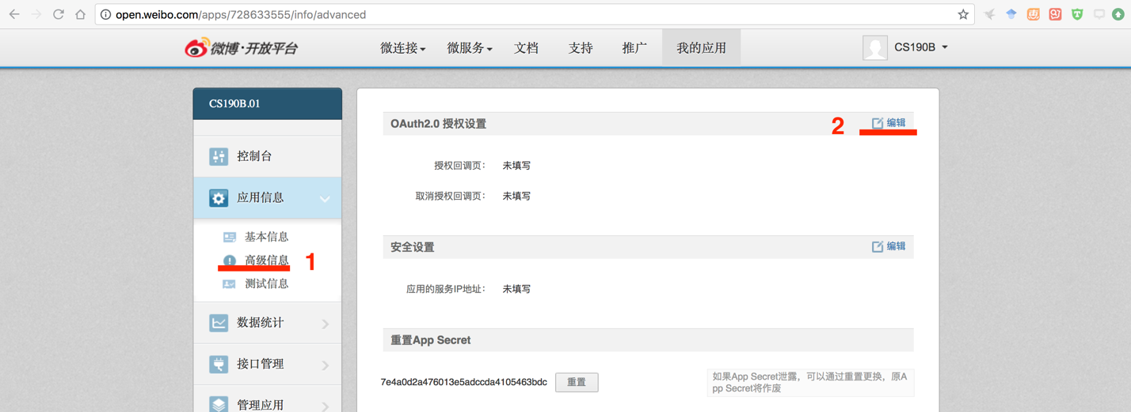

1. You should have to fill the two empty fields with an URL address. In most cases, it does not matter what you choose. The first field(接权回调页) will be your **Redirect URI**, which is needed to authenticate your application. We set this to <https://api.weibo.com/oauth2/default.html>， but any valid URL should be fine.

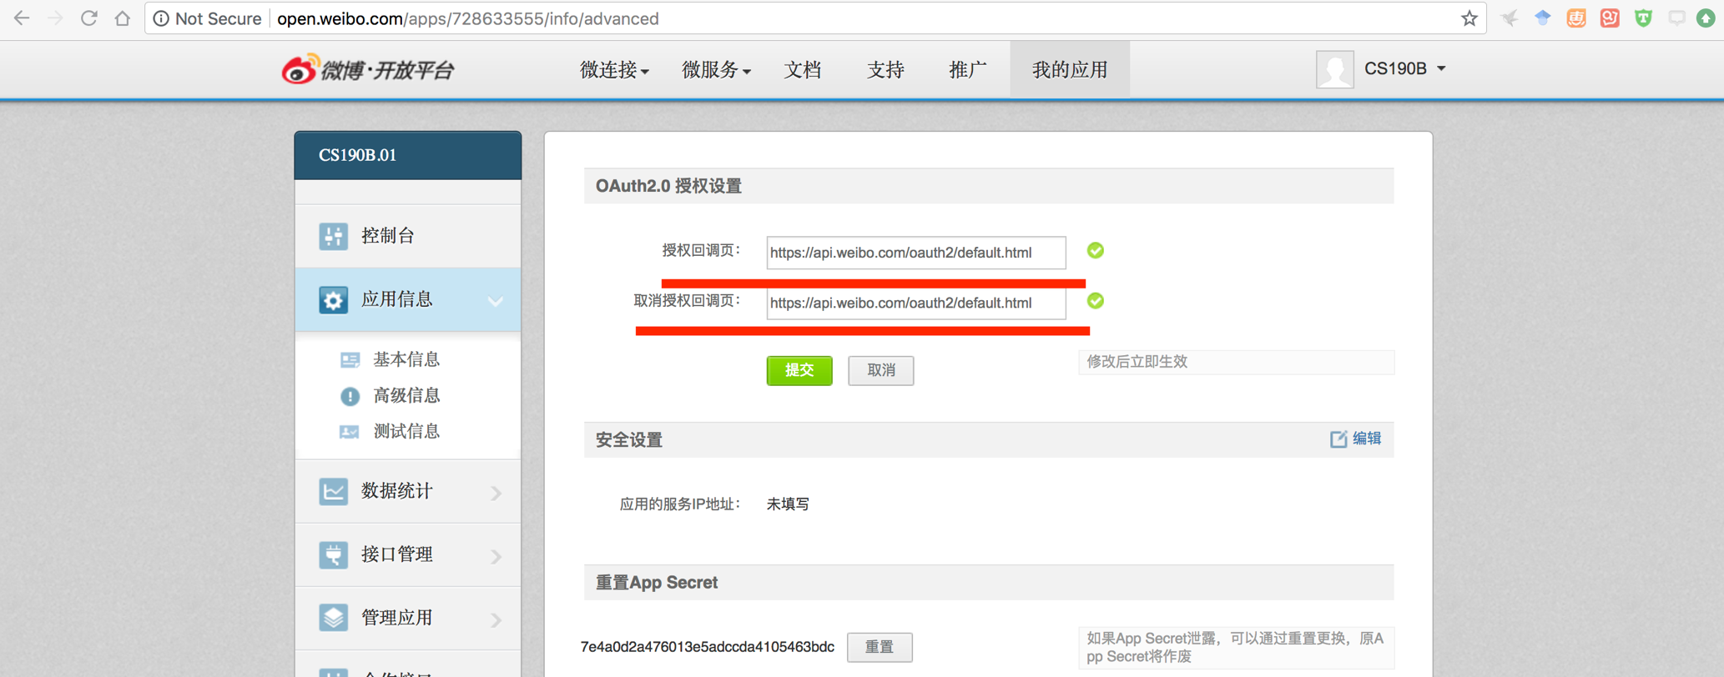

1. Congrats! By now you should have the App Key, App Secret and a Redirect URI. This is all you need to start using the Weibo API(sinaweibopy).

**Step 3: Install the package *sinaweibopy***

Open the command line window, type: pip install sinaweibopy, which is very easy to use.

**Step 4: Run the code**

1. Please find the code Weibo.py attached on the blackboard, and save the file on desktop.
2. Replace the keys you saved from the Weibo API at the appropriate locations.
3. Run the code and you would see some information in the shell. And we store what we extract into a txt file.